Story 02 - Book Statistics

## Description

As a user

I want to see the the most expensive book in the library

And the total value of the collection.

## Wireframe

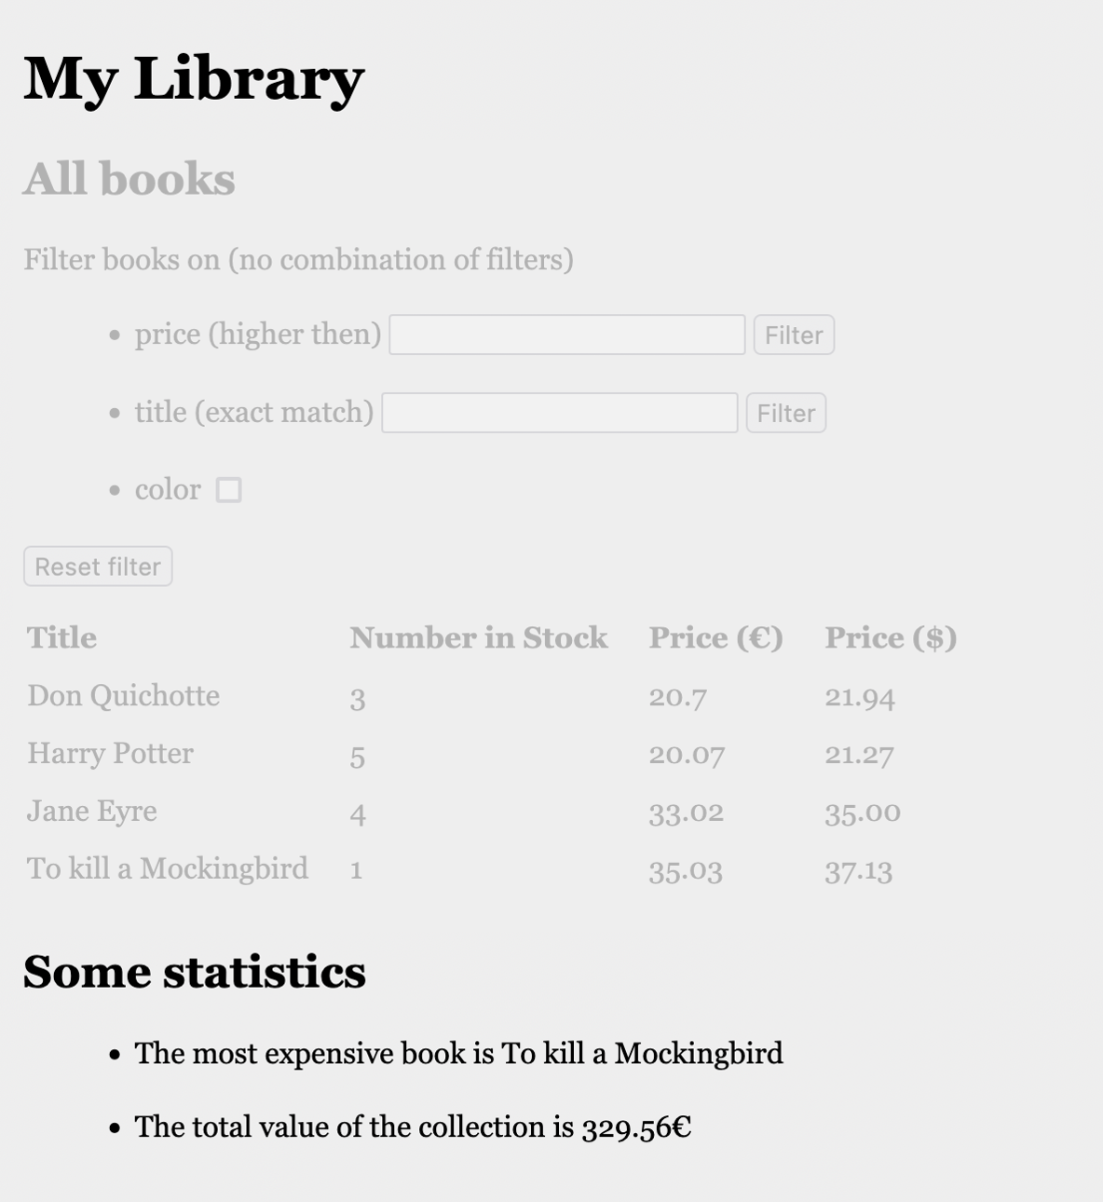

## Acceptance Criteria

* Below the table overview following information is shown as list
  + The title of the most expensive book
  + The total value of the collection (in €)

## Technical Requirements

* The total value is calculated as $∑$ (price*numberInStock)
* The asked values are fetched from back-end by
  + <http://localhost:8080/api/book/totalValue> (response: double)
  + <http://localhost:8080/api/book/mostExpensive> (response: JSON object with fields “title”, “numberInStock”, “price”, “inColor”, “priceInDollar”).